The nucleus in a cell contains all the genes that control all the characteristics of an organism.

Respiration...

Glucose + Oxygen Carbon dioxide + Water

....is a bit like burning a fuel.

Fuel + Oxygen Carbon dioxide + Water

Key scientific ideas – cells 3

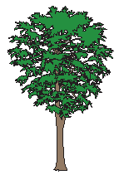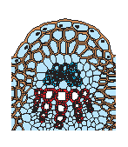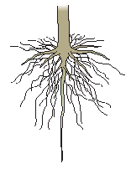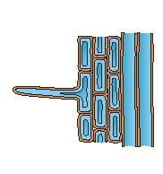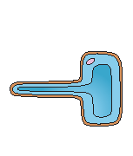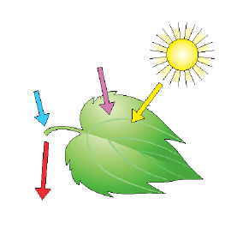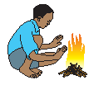 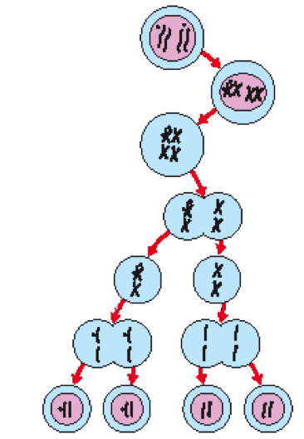

Chromosomes are made up of genes and genes are made of DNA.

Exercise helps to keep the body’s organs and systems working properly.

Chemicals from smoking, alcohol and drugs can affect how well different parts of the human body work.

Photosynthesis requires chlorophyll in plant cells, light, carbon dioxide and water in order for the plant to make food.

The leaves and roots of a plant are adapted so that photosynthesis can take place efficiently.

When fertilisation occurs half the chromosomes from one parent join with half the chromosomes from the other parent to produce a new individual.

Selective breeding, either by nature or by humans, can increase the chance of certain genes passing from one parent to the offspring.

Veins in leaves and stems

Tree

Organism

System

Root

Root hair tissue

Tissue

Organ

Cell

Root hair cell

Energy transferred by sunlight

Food transported to all of the plant

Water from the roots

Carbon dioxide from the air

**Photosynthesis**

Like burning, respiration transfers **energy** to the surroundings by heating.

The chromosomes now separates from each other and move to opposite ends of the cells.

The second cell division occurs.

Parent cell with four chromosomes.

Chromosomes replicate forming pairs of chromatids.

Pairs of chromosomes arrange themselves in the centre of the cell.

The chromosomes separate and move to opposite ends of the cell.

The first cell division occurs.

## The formation of sex cells

Based upon an idea and approach developed by The Cams Hill Science Consortium.

**It’s all about respiration, photosynthesis and reproduction**

**Photosynthesis enzyme**

carbon dioxide + water glucose + oxygen

**Energy transferred by sunlight**

**Respiration enzyme**

glucose + oxygen carbon dioxide + water

**Energy**

**Useful vocabulary**

Cell

Digestion

Organ

Cell wall

Cell membrane

Chlorophyll

Photosynthesis

Respiration

Chloroplasts

Genes

Fertilisation

Characteristics

Inherited

Selective breeding

Fertilisers