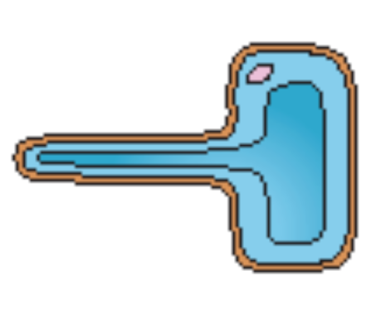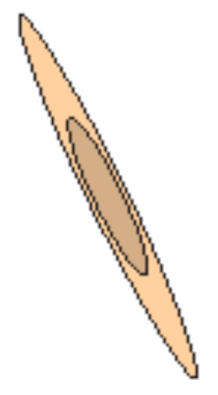Key scientific ideas – cells 1

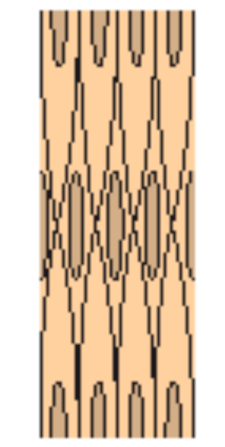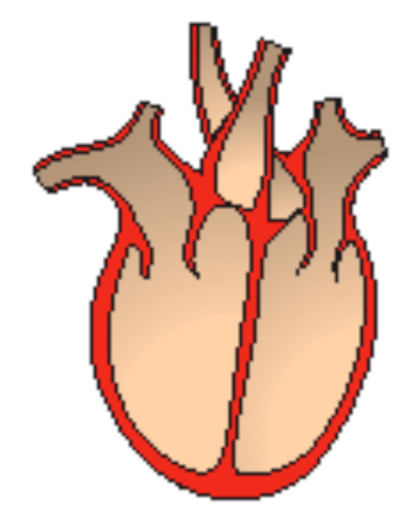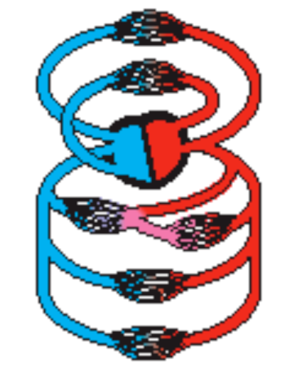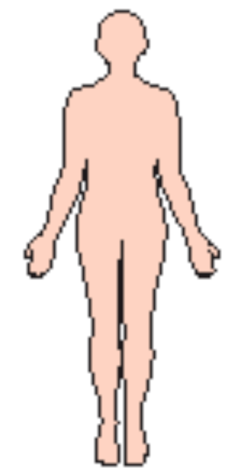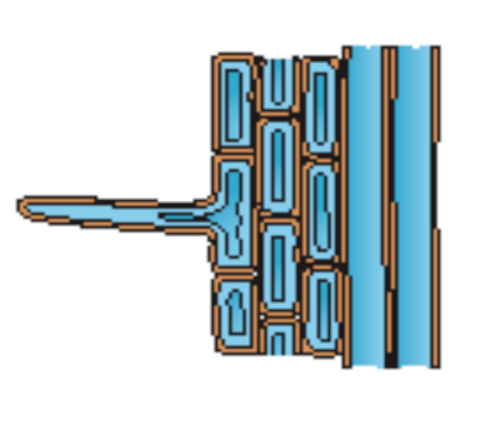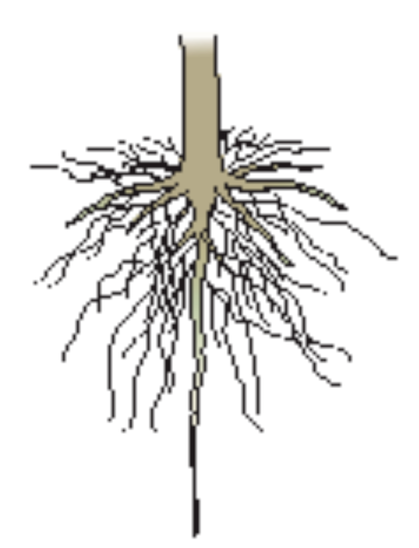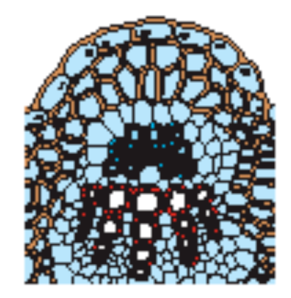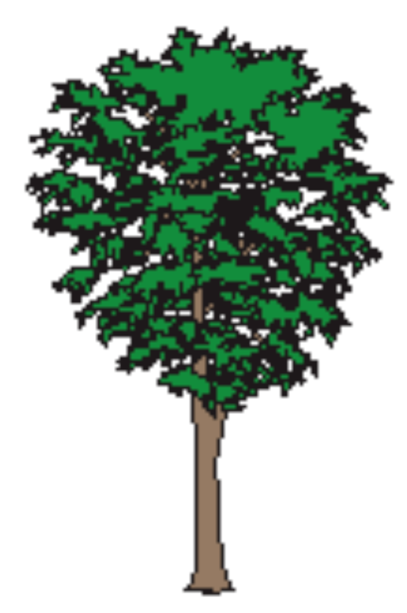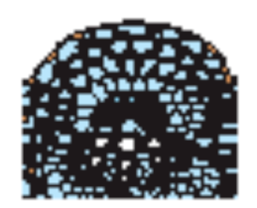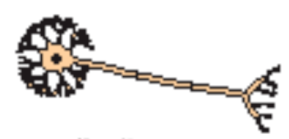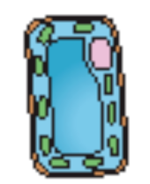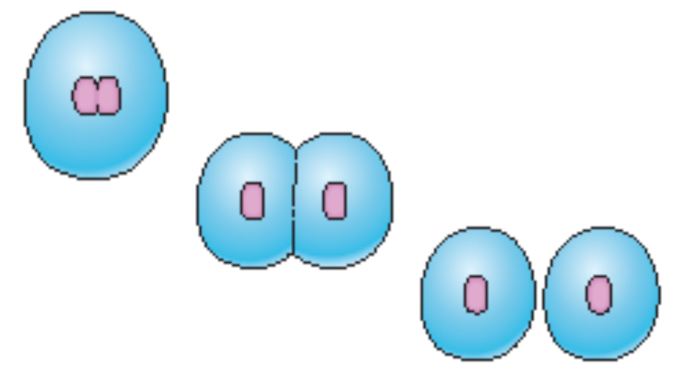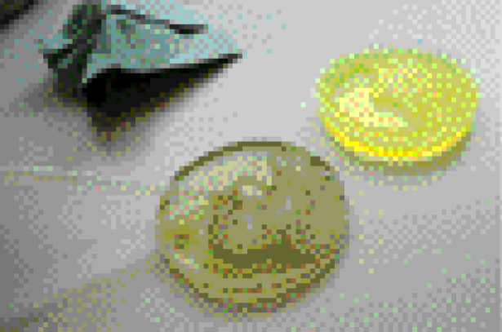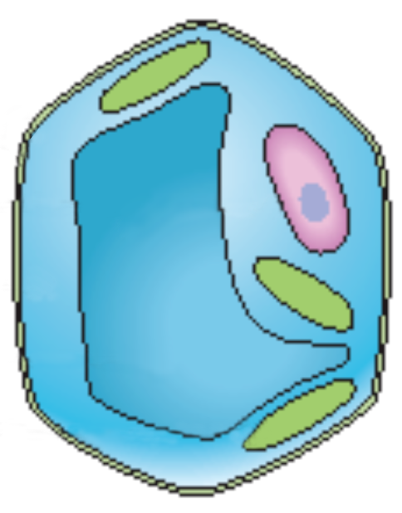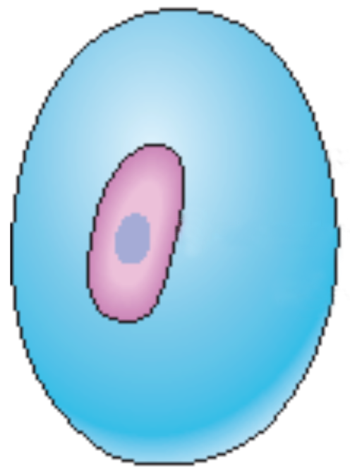

organism

system

organ

tissue

specialised cell

circulatory system makes up part of the human body

circulatory system

heart

muscle  
tissue

muscle  
cell

organism

system

organ

tissue

specialised cell

veins in leaves and stems make up the transport system

root

root

tissue

root hair  
cell

transport system makes up part of a plant

Cell wall

Cell membrane

Nucleus

Cytoplasm

Vacuole

Chloroplast

## Useful vocabulary

Cell Tissue

Cytoplasm Organ

Chloroplast Cell division

Cell wall Fertilisation

Cell membrane Sperm cell

Nucleus Egg cell

Vacuole Organism

muscle tissue

plant tissue

Organisms with specialised cells can function more efficiently and effectively.

## Cells, tissues, organs

• Similar specialised   
cells can be grouped together and form tissues.

• Tissues group together to form organs.

• Organs grouped together form systems and the whole thing is called an organism.

Movement Respiration Sensitivity Growth Reproduction Excretion Nutrition

**Typical animal cell**

**Typical plant cell**

This 3-D model shows   
how an organism grows because of cell division and not because the individual cells get bigger.

## How cells divide

palisade cell

root hair cell

muscle cell

sperm cell

red blood cell

nerve cell

## Specialised cells and tissues

Based upon an idea and approach developed by The Cams Hill Science Consortium