Key scientific ideas – energy 1

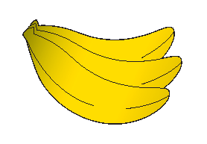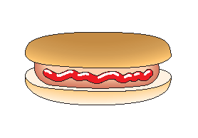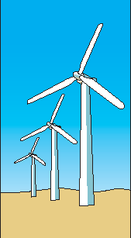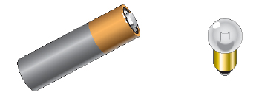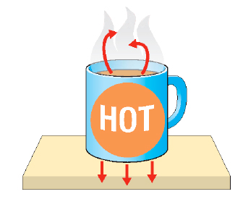

The amount of energy stored in food is measured in joules.

**Energy can be stored:**

* In food and fuels (chemical energy)
* In stretched elastic bands and springs (elastic potential energy)
* In moving objects (kinetic energy)
* Inside atoms (nuclear energy).

Fossil fuels are convenient concentrated stores of energy.

The sun is the ultimate source of nearly all the energy on the earth.

In a circuit, energy is transferred   
from the cell to the bulb by an electric current.

Plants get their energy from the sun.

Surroundings

**The energy transfers in a torch**

Electric current

Heating

Light

Bulb

Cell

Conduction

Convection

Radiation

## Useful vocabulary

Energy transfer Kinetic Renewable

Food chain Potential Electric current

Heating Chemical Surroundings

Light Stored Convection

Sound Producer Conduction

Joule Consumer Radiation

Fossil fuel

**Energy is transferred by heating by:**

* Conduction
* Convection
* Radiation

**Energy transfers by heating**

Based upon an idea and approach developed by The Cams Hill Science Consortium.