Key scientific ideas – energy 2

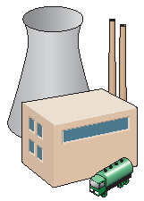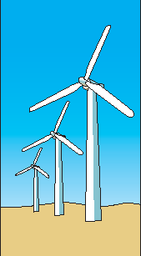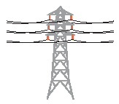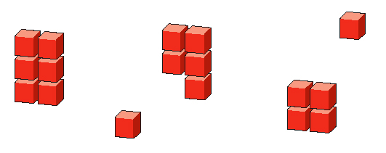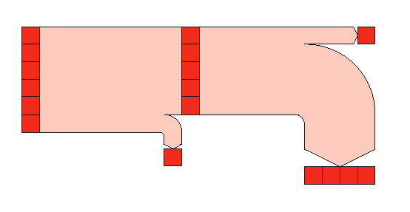

## Useful vocabulary

Energy transfer Stored Renewable

Heating Conservation Electric current

Light Efficiency Surroundings

Sound Sankey diagram Potential

Chemical Dissipation

Kinetic Fossil fuel

**Energy is transferred by heating by:**

* Conduction
* Convection
* Radiation.

The amount of energy transferred is measured in joules.

Plants get their energy from   
the sun.

Fossil fuels are convenient concentrated stores of energy.

In a circuit, energy is transferred from the cell to the bulb by an electric current.

Ordinary electric light bulbs are not very efficient.

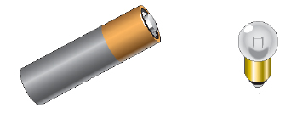

Electric current

Light

Heating

Bulb

Cell

Surroundings

**The energy transfers in a torch**

**The energy transfers in a torch**

Surroundings

Surroundings

Surroundings

Cell

Bulb

Light

Heating

Electric current

Electric current

Heating

Light

Heating

Energy in surroundings

**The energy transfers in a torch**

Based upon an idea and approach developed by The Cams Hill Science Consortium.