Key scientific ideas – forces

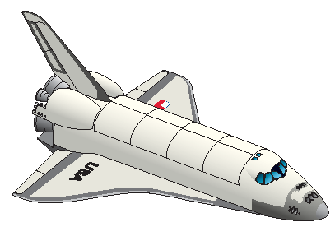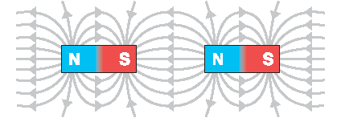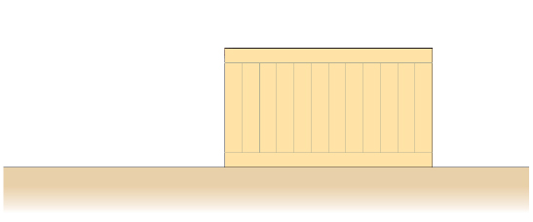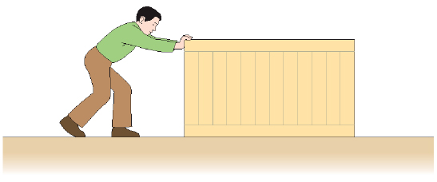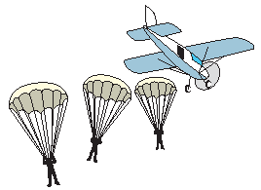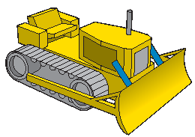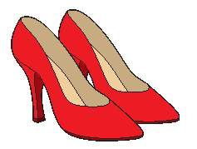

A force cannot be ‘put into’ or ‘stored in’ an object.

**In the ‘perfect’ world**… scientists often find it easier to think of what would happen if we lived in a world without friction.

**Friction** arises when two surfaces move over one another. Air resistance and water resistance are friction forces caused by the movement of something through air or water.

If an object is **not moving**, the resultant force acting on it is zero.

If an object is moving at a **steady speed** in a straight line, the overall (resultant) force acting on it is zero.

When there are several forces acting, the overall force is called the resultant force.

### Non-contact forces

Some forces affect an object without touching it. The forces of gravity, magnetism and electrostatics are all examples of non-contact or field forces.

### Identifying forces

* Which forces are acting?
* Where are the forces acting?
* What are the size and direction of the forces?

**Predicting and explaining motion**

1. Identify the size and direction of all the forces acting on the object you are interested in.
2. Add the forces acting on the object together to find the overall ‘resultant’ force on it.
3. Use the following rules:

* if there is a total (resultant) force acting on the object, this will change the motion of the object, in the direction of the force;
* if the resultant force is zero, the motion of the object will not change.

### Contact forces

One object exerts a force on another as long as they are touching.

Contact forces exist for as long as the objects are touching. Once the objects are apart, the forces no longer exist and the interaction has ended.

Forces come in pairs.

**‘Force arrows’ help to show the forces acting in a particular situation.**

The **length** of a ‘force arrow’ can be used to indicate the size of the force.

The **direction** of a ‘force arrow’ is often more important than the precise point at which it acts.

Box

Floor

This arrow shows the size and direction of the force exerted by the floor on the box

This arrow shows the size and direction of the force exerted by the box on the floor

## Useful vocabulary

Contact force

Exerted by

Constant

Tension

Opposing

Unbalanced

Weight

Balanced

Mass

Acting on

Stationary

Friction

Attraction

Newton

Reaction

Moving

Gravity

Surface

Pair

Force exerted by floor on the box  
(friction – tries to stop the box moving)

Force exerted by person on the box

Floor

Box

Based upon an idea and approach developed by The Cams Hill Science Consortium.

**Pressure**

Forces can be spread out over a larger area to reduce the **pressure** on the surface.

When forces are concentrated on a small area the pressure is bigger.