Key scientific ideas – interdependence

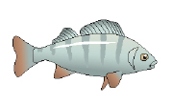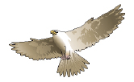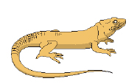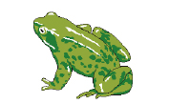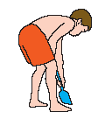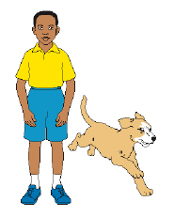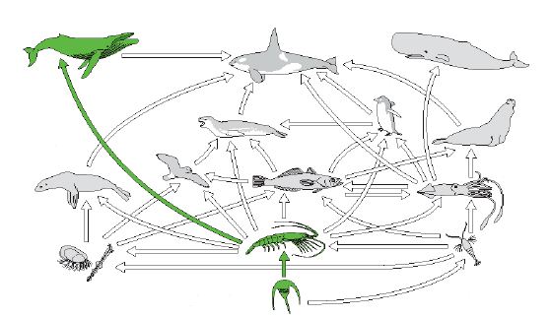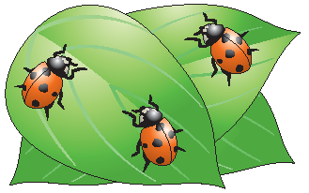

**5 Vertebrate groups**

Amphibians

Reptiles

Birds

Fish

Mammals

**A pyramid of numbers**

Grass

Rabbits

Fox

**Animals**

**Vertebrates Invertebrates**

Amphibians Insects

Reptiles Snails

Birds Worms

Fish Jellyfish

Mammals Squid

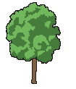

**Plant**

**With flowers**  
Daisy; dandelion; rose; strawberry; potato; trees; grass

**Without flowers**  
Mosses; ferns; seaweeds

Energy is transferred through a food chain by feeding.

Plants get their energy from the sun.

The sun is the ultimate source of nearly all the energy on the earth.

Only 10% of the energy stored in the organisms at one level in a food chain is transferred by feeding and digestion to the organisms at the next level.

Squid

Elephant seal

Penguins

Other birds

Leopard seal

Fish

Krill

Other herbivorous zooplankton

Carnivorous zooplankton

Phytoplankton

Other seals

Sperm whale

Small tooth whale

Baleen whale

**Food web**

**Food chain**

Sun

Phytoplankton

Krill

Baleen whale

## Useful vocabulary

Energy transfer Predation Producer Keys

Food chain Competition Environmental factors Ecosystem

Adaption Food web Carnivore Classification

Variation Diversity Prey Consumer

Habitat Population size Identification Species

Living things interact with each other and their physical environment. Changes that occur in their environment can affect them, for example:

* Global warming
* Acid rain
* Pollution
* Insecticides, herbicides and pesticides.

Based upon an idea and approach developed by The Cams Hill Science Consortium.