Key scientific ideas – particles
Particles can be of different sizes. This could explain how some chemicals can pass through membranes and others can’t.
 | Solid | Liquid | Gas
Diagram
How are the particles arranged? | Fixed patten | Random | Random
How are the particles moving? | Vibrating on the spot | Moving over each other | Fast moving
How close are the particles? | Close | Close | Far apart
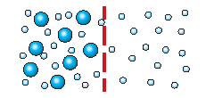
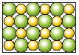
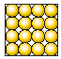
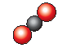
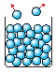
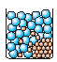
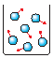
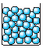
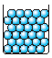
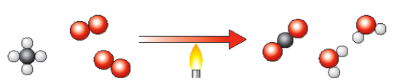
The names of some compounds can tell you what elements are in them, for example compounds ending in:
....ate contain lots of oxygen
....ite contain some oxygen
....ide contain no oxygen (except for
oxides and hydroxides)

Molecules are made of atoms joined together (bonded), for example, carbon dioxide.
…and lots more

Sodium chloride (NaCl)
Compounds can’t be separated easily.
Compounds have a fixed combination of different types of atoms.
There are just over 100 different elements.

Chlorine (CL2)
Sodium (Na)
Elements contain only one type of atom.
The particles nearest the flame begin to vibrate more.

Conduction
Gradually energy is transferred from particle to particle along the bar by vibration.
This model can explain
Evaporation
The fastest-moving particles escape from the surface of the liquid.
Dissolving
Particles from the solid break off and spread out amongst the particles of the liquid.
Carbon dioxide + Water
Natural gas + Oxygen
(Methane
Product
Reactants
Chemical reactions

Conservation of mass. In a chemical reaction…

Toaster
Reactants
Bread and oxygen
Product
Smoke and toast
Smoke

...there are the same number of particles at the end of the reaction as there were
at the beginning
...no particles get lost or destroyed ...
...the particles
are rearranged
in the reaction
...the products have the same mass as
the reactants

Useful vocabulary
Particle Atom Displacement
Compressible Compound Equation
Diffusion Decompose Neutralisation
Expansion Element Product
Gas pressure Formula Reactant
Symbol Molecule Reactivity
Mixture Salt

Word equation
Methane + oxygen carbon dioxide + water

Symbol equation
CH₄ + 2O₂ CO₂ + 2H₂O

Based upon an idea and approach developed by The Cams Hill Science Consortium

